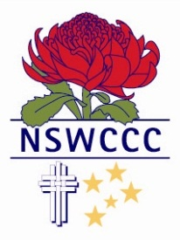

NSW COMBINED CATHOLIC COLLEGES SPORTS ASSOCIATION

MAXWELL STEWART
Blue Award
2015
Rugby
St Edward’s College Gosford

Max has represented New South Wales Combined Catholic Colleges in the Boys Under 18 Rugby team for the past two years and in 2015 was one of the outstanding players of the New South Wales Combined Catholic Colleges Under 18 Team.
Max played hooker and excelled in this position during the competition. He led the forward pack by example and his love for contact contributed to our team going forward. He played a crucial role in the success of the team through his leadership and rugby skills. He was selected in the NSW Schools 2nd XV Team.
Max has been an enthusiastic member of Rugby teams at all levels. On and off the field he shows determination in his play and outstanding sportsmanship. He has displayed consistent commitment to the team and he has always contributed positively to the team environment.
Max is a very promising rugby talent for the future.

